IST: Task 1

Utsav Kashichhwa

IST: Task 1

Design Portfolio

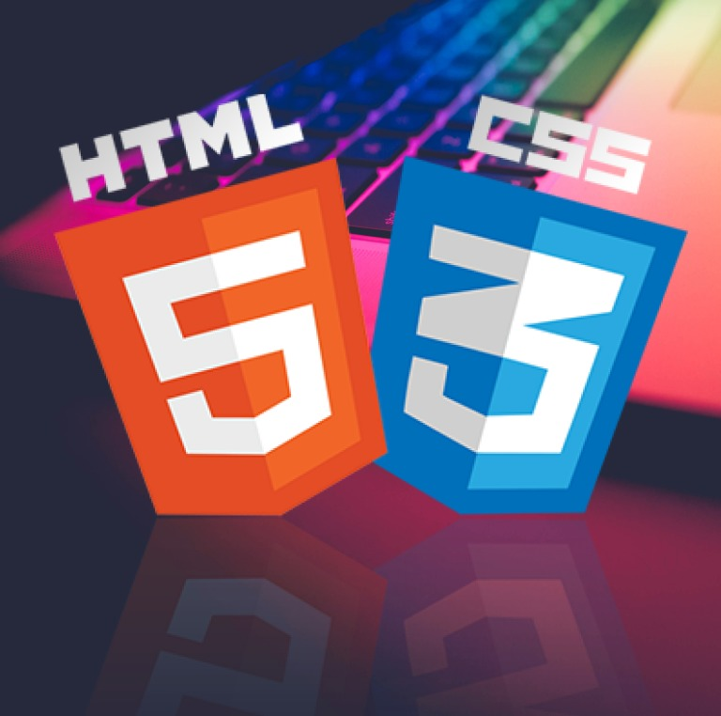

## Contents

Defining and analysing the problem …………………………………………………………………………………….2

Problem statement …………………………………………………………………………….……………………2

Constraints ………………………………………………………………………………………………………………3

Designing possible solutions ………………………….…………………………………………………………………….5

Site map …………………………………………………………………………………………………………..………5

Storyboards ………………………………………………………………………….…………………………………6

Producing the solution ……………………………………………………………………………………………..……….10

Evaluation ………………………………………………………………………………………………………………………….15

Comparison with criteria ……………………………………………………………………………………….15

PMI Chart ………………………………………………………………………………………………………………16

## Defining and analysing the problem

### Problem Statement

The client, who is a school student, requires an E-portfolio to be developed using HTML and CSS. This website should showcase the client’s identity by containing their work, goals, and achievements. The client has also requested that the website to be used for educational purposes and should contain information about the internet.

The website needs to contain 5 webpages:

* A home page for information about the website,
* An about me page for information about the client,
* A page that informs and answers general questions about the internet,
* A blank page for the client’s future assessment task,
* And a page containing contact details of the client.

The developer was notified of this task on the 18th of March 2022 and has until the 28th of April to complete the website and a design folio outlining the process of developing the website.

#### Aims and objectives

|  |  |
| --- | --- |
| Aim | How will this be achieved |
| To create a website consisting of five webpages that has an aesthetically pleasing design and contains a smooth and user-friendly navigation system. | This will be achieved through the use of CSS to style the website. A consistent colour palate and structure will be used through out the website, and navigation elements will have the ‘transition’ property to make smooth animations, and to help the user recognise interactive/clickable features. |
| To include information about the client and the internet that is highly detailed, accurate and useful. The website should be structured in a way that allows the user to effortlessly find the specific information that they need. | The topic should be researched using tools such as the IST textbook, or reliable sources from the internet. Sources should be included for the user to factcheck or read further into the topic. Headings and subheadings should be used effectively to |
| To make the website accessible on a range of devices with different screen resolutions. When viewed on a large screen, the website will take advantage of the extra white space, while the website should still be viewable on mobile. | Percentages should be used instead of pixels in CSS to allow the website elements such images and whitespaces to resize with the webpage. The navigation and website layout could possibly also change when the website is view on a thinner resolution such like a mobile phone. |

### Constraints

#### Technical

The developer of the website prefers to work on his desktop, however, has to work on his laptop or school computers when at school. To solve this, GitHub will be used to transfer work between devices.

#### Operational

The developer is unfamiliar with HTML and CSS and is unsure of many of the concepts required to build the website. To help with this, the develop will use online resources and tutorials to assist in the creation of the website.

#### Time

The task was given on the 18th of March 2022 and is due on the 28th of April. This means that almost 6 weeks was allocated for the task. This is a satisfactory length of time; however, it involves many different sections. To ensure that every part is completed, and is allocated the time required, a Gantt chart has been created to assist the developer in time management.

|  |  |  |  |  |  |  |
| --- | --- | --- | --- | --- | --- | --- |
| Task | Week 1 | Week 2 | Week 3 | Week 4 | Week 5 | Week 6 |
| Planning |  |  |  |  |  |  |
| * Analysing the problem |  |  |  |  |  |  |
| * Designing possible solutions |  |  |  |  |  |  |
| * Researching for option topic |  |  |  |  |  |  |
| Creating the website |  |  |  |  |  |  |
| * HTML |  |  |  |  |  |  |
| * CSS |  |  |  |  |  |  |
| Finishing Documentation |  |  |  |  |  |  |
| * Annotating screenshots |  |  |  |  |  |  |
| * Evaluation |  |  |  |  |  |  |
| Submission |  |  |  |  |  |  |
| * Final changes |  |  |  |  |  |  |
| * Submission |  |  |  |  |  |  |

#### Financial

The developer is on a low budget so buying stock image and icons is unaffordable. To solve this, the developer will use either material that is either free or licensed under Creative Commons.

#### Ethical

Avoid using copyrighted material and other people’s work without having the proper licencing or permission. Give sources and credit to free information, photos or code.

## Designing possible solutions

### Site Map

### Storyboards

#### Storyboard 1

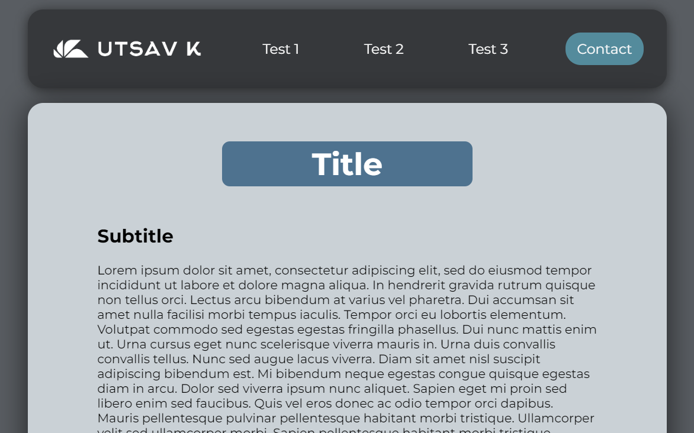

|  |  |  |
| --- | --- | --- |
| Plus | Minus | Interesting |
| * Minimalistic design * Light colour palate is easy on the eyes * Use of rounded borders makes the website * Large title with a coloured border to make it obvious which page the user is on | * The margin between each header and main makes the website feel disconnected * The lack of colour or images makes the website look bland * The outside margins don’t allow much space for actual content | * Use of shadows make the main elements such as the header and main pop out |

#### Storyboard 2

|  |  |  |
| --- | --- | --- |
| Plus | Minus | Interesting |
| * The navbar takes minimal horizontal space, making it work well for mobile devices. * Good use of icons to indicate interactive elements. | * No good indication of which page the user is currently on * This navbar doesn’t work well on desktop as there is a lot to blank space. | * Using either JavaScript or more advanced CSS, it could be possible to make a regular navbar change to this design when the window is resized. |

#### Storyboard 3

|  |  |  |
| --- | --- | --- |
| Plus | Minus | Interesting |
| * Dark theme makes the website easier to look at * Space on right side of the webpage leaves room for small elements like images or icons to assist in explaining the test. * The assessment navigation allows the user to hover over it and select between the two, saving space making stuff easier to find | * The change in colour of the current page on the navbar is slightly subtle. An underline or border could improve this * The background is very plain. More colours or an image could be used. | * The large margin would suit the homepage, but a page with more text would need more space. |

#### Storyboard 4

|  |  |  |
| --- | --- | --- |
| Plus | Minus | Interesting |
| * Basic, simple design and colour scheme * Can be resized to fit mobile devices | * Isn’t very visually appealing or aesthetical * Text looks too stretched out on larger devices. Margins with percentages could be used to fix this. | * More colours, images and styling could be used to make this website more interesting * The logo uses an icon and text instead of an image, which makes it easier to edit. |

## Producing the solution

### Annotated screenshots of the final design

#### Navbar

#### Homepage

#### About page 1/2

#### About page 2/2

#### Internet and Website Development page

#### Contact Page

## Evaluation

### Comparison with criteria

#### Criteria 1:

*To create a website consisting of five webpages that has an aesthetically pleasing design and contains a smooth and user-friendly navigation system.*

The final design fully met this criterion. The website contains five webpages that has a simple and minimalistic design. The links in the navigation bar change colours and have a smooth underline when hovered on, and the current page is a different colour to indicate with page the user is on.

#### Criteria 2:

*To include information about the client and the internet that is highly detailed, accurate and useful. The website should be structured in a way that allows the user to effortlessly find the specific information that they need.*

The website mostly met this criterion. The website includes information about the client and their contacts and uses iframes and links to showcase their projects and contact details. The information about the internet wasn’t highly detailed, however is simplified to be easily understood by the average person. Subtitles and subheadings are used to organise the page so the user can easily find the information they are looking for, and the two assessment tasks are grouped together in a dropdown menu.

#### Criteria 3:

*To make the website accessible on a range of devices with different screen resolutions. When viewed on a large screen, the website will take advantage of the extra white space, while the website should still be viewable on mobile.*

The website somewhat met this criterion. Percentages were used effectively so the website could be viewed on laptop and tablet screens, but the time constraints and limitations in the developer’s technical ability meant that a resizing mobile navbar was not added. Most of the pages can still be viewed on mobile, with the formatting slightly off, but the contact page looks completely broken when viewing from a lower resolution.

### PMI Chart

|  |  |  |
| --- | --- | --- |
| Plus | Minus | Interesting |
| * Dark backgrounds make it easier on the eyes * Interactive elements such as an embedded google maps iframe to show the client’s school, and iframes to showcase the client’s projects * Clickable and navigation elements change colour or have animations when hovered on to make them more obvious to the user * Current page is coloured and underlined on the navbar, and a large heading is used to let the user know exactly where they are * Use of subheadings and subtitles to group information * Shadows are used on certain elements to make them pop out more and make the website more visually appealing | * Limited colour scheme, consists on only black, aqua and white * Formatting breaks when view at lower resolutions, especially the contact page * The about page is quite long. Could have been divided into different pages, or a content links could be added to help the user quickly find information. * More images and icons could have been used on the Internet and Website Development page to help explain content visually | * Replit, a website that hosts and runs your code included a feature to embed projects in other websites. This was done with some of the client’s projects. * Icons from font awesome were used in the contact page * Separate CSS files were used for the navbar to make the code more organised |